Bahria University,

Karachi Campus



LAB EXPERIMENT NO.

**_01_**

LIST OF TASKS

|  |  |
| --- | --- |
| TASK NO | OBJECTIVE |
| 1 | You work at a public library that wants to digitize its book catalog and membership management. Your task is to create a Library Management System using Google Colab to allow librarians to add/edit book records and manage member information. |
| 2 | You are a data analyst at a real estate company. You have been given a dataset of housing sale prices in different regions over the past 5 years. Load the data into Pandas and preprocess it by handling missing values and formatting columns. |
| 3 | You work for an e-commerce company and have been given a dataset with information on customer orders over the past year. Load the data into Pandas, analyze it using methods like .info(), .describe(), Which products have the highest/lowest sales? Which customer segments spend the most |
| 4 | You are a data analyst working for an automobile company. You have been provided with the Vega dataset which contains details on different vehicle models like price, engine size, horsepower, dimensions etc. |

Submitted On:

**Date: _____18/02/2024_____**

1. You work at a public library that wants to digitize its book catalog and membership management. Your task is to create a Library Management System using Google Colab to allow librarians to add/edit book records and manage member information.

import pandas as pd

import ipywidgets as widgets

books_df = pd.DataFrame(columns=['Title', 'Author', 'Genre', 'Year'])

def add_book(title, author, genre, year):

    global books_df

    books_df = books_df.append({'Title': title, 'Author': author, 'Genre': genre, 'Year': year}, ignore_index=True)

def edit_book(index, title, author, genre, year):

    global books_df

    books_df.loc[index] = {'Title': title, 'Author': author, 'Genre': genre, 'Year': year}

def delete_book(index):

    global books_df

    books_df.drop(index, inplace=True)

title_text = widgets.Text(description='Title:', style={'description_width': 'initial'})

author_text = widgets.Text(description='Author:', style={'description_width': 'initial'})

genre_text = widgets.Text(description='Genre:', style={'description_width': 'initial'})

year_text = widgets.Text(description='Year:', style={'description_width': 'initial'})

add_book_button = widgets.Button(description='Add Book')

edit_book_button = widgets.Button(description='Edit Book')

delete_book_button = widgets.Button(description='Delete Book')

def handle_add_book(button):

    add_book(title_text.value, author_text.value, genre_text.value, year_text.value)

    print('Book record added successfully!')

def handle_edit_book(button):

    # Get the selected index from the dropdown

    index = dropdown_index.value

    edit_book(index, title_text.value, author_text.value, genre_text.value, year_text.value)

    print('Book record edited successfully!')

def handle_delete_book(button):

    # Get the selected index from the dropdown

    index = dropdown_index.value

    delete_book(index)

    print('Book record deleted successfully!')

add_book_button.on_click(handle_add_book)

edit_book_button.on_click(handle_edit_book)

delete_book_button.on_click(handle_delete_book)

dropdown_index = widgets.Dropdown(options=books_df.index, description='Select Book:', style={'description_width': 'initial'})

book_widgets = widgets.VBox([title_text, author_text, genre_text, year_text, add_book_button, edit_book_button, delete_book_button, dropdown_index])

book_widgets

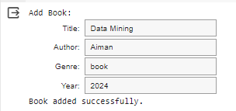

2 - You are a data analyst at a real estate company. You have been given a dataset of housing sale prices in different regions over the past 5 years. Load the data into Pandas and preprocess it by handling missing values and formatting columns.

* Read csv Info()

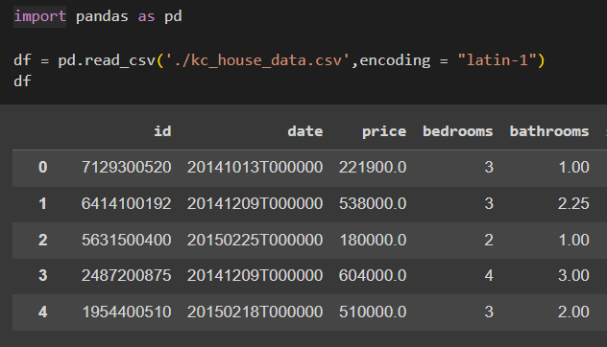

Shape

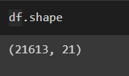

Describe after dropping some columns

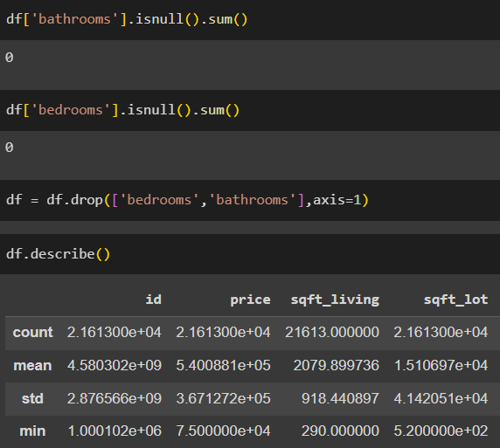

Finding Unique and repeated values

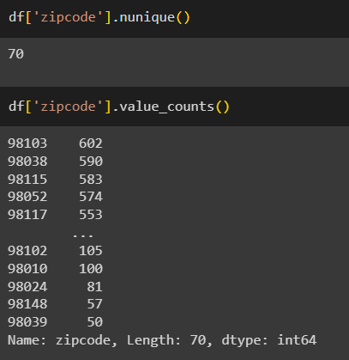

1. You work for an e-commerce company and have been given a dataset with information on customer orders over the past year. Load the data into Pandas, analyze it using methods like .info(), .describe(), Which products have the highest/lowest sales? Which customer segments spend the most?

* Read Csv

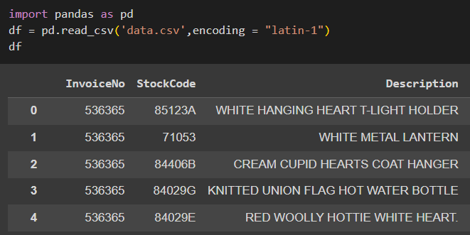

* Finding and removing Null values

* Finnding Duplicates

Dropping Duplicates

Finding Highest and lowest sales

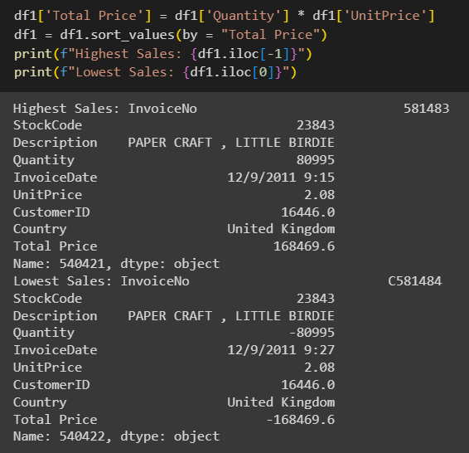

Finding Segmentation wrt Country

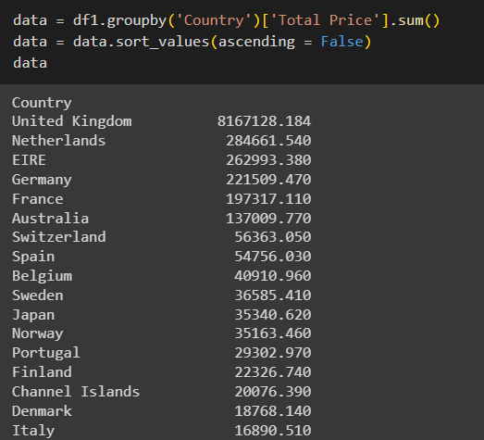

1. You are a data analyst working for an automobile company. import pandas as pd

import matplotlib.pyplot as plt

import seaborn as sns

from vega_datasets import data

import altair as alt

vega_df = data.cars()

vega_df.columns

vega_df.head()

plt.figure(figsize=(4,4))

plt.scatter(vega_df['Displacement'],vega_df['Acceleration'],alpha = 0.5) #alpha = blurry effect

plt.title("Scatter Plot Displacement vs Acceleration")

plt.ylabel('Displacement')

plt.xlabel('Acceleration')

plt.show()

plt.figure(figsize = (4,4))

sns.histplot(vega_df['Horsepower'],kde = True) #kde = line

plt.title("Hist Plot Horsepower")

plt.ylabel('Frequency')

plt.xlabel('Horsepower')

plt.show()

origin_stats = vega_df.groupby('Origin').agg({'Weight_in_lbs':['mean','median','std']}).reset_index()

origin_stats.columns = ['Origin','Mean Weight','Median Weight','Weight Std']

alt.Chart(origin_stats).mark_bar().encode(

    x = 'Origin',

    y = 'Mean Weight',

    color = alt.Color('Origin',legend = None),

    tooltip = ['Origin','Mean Weight','Median Weight','Weight Std']

).properties(

    height = 300,

    width = 400,

    title = "Altair Plot of Groupby wrt Weight"

).interactive()

